Step – 1

Prerequisite : SalaryCSVGenerator.exe file

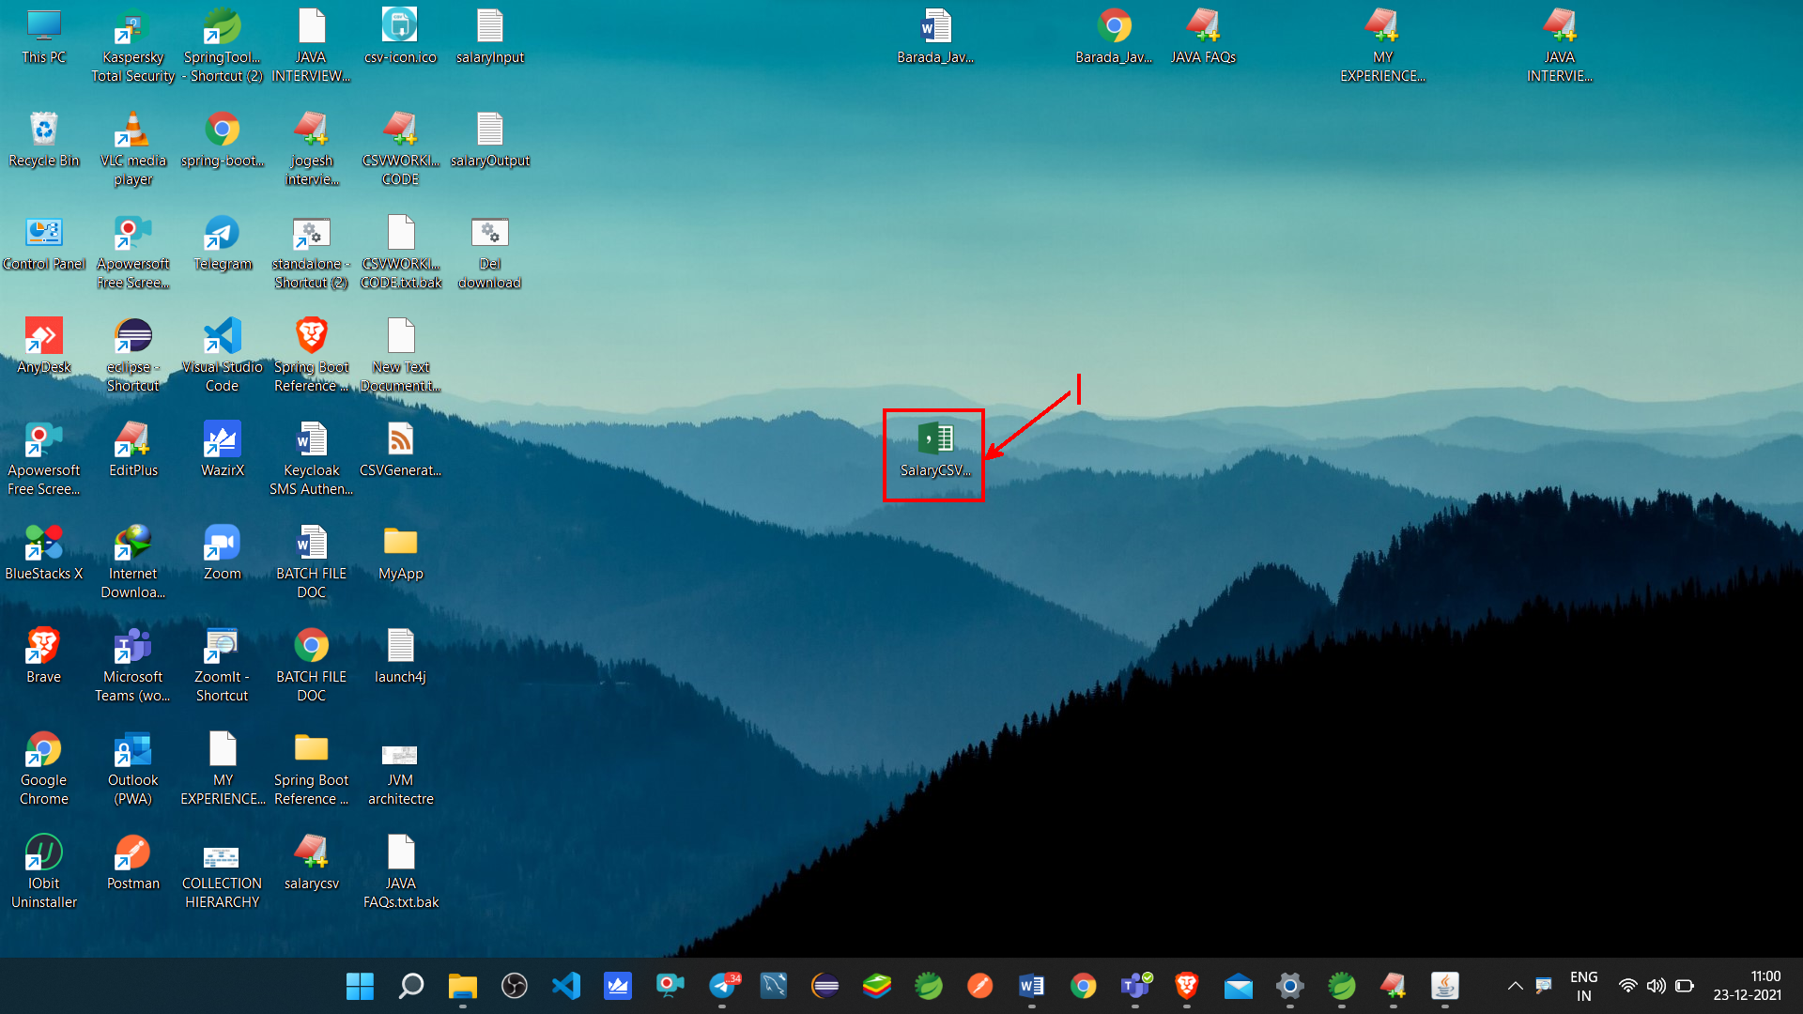

Step -2

Double click and Run that .exe file and allow all required permission .

Now Command prompt console will appear as shown below :

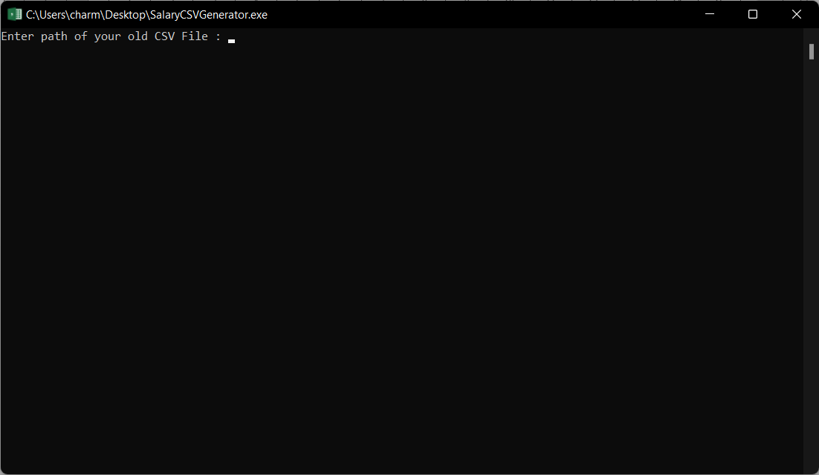

Step -3

You can see the command prompt asking for your old csv file path . so we need to add path details of our OLD CSV file . To get path of your CSV file ,follow below steps ;

->Right click on your old CSV file

->Go to properties

->copy location and file name

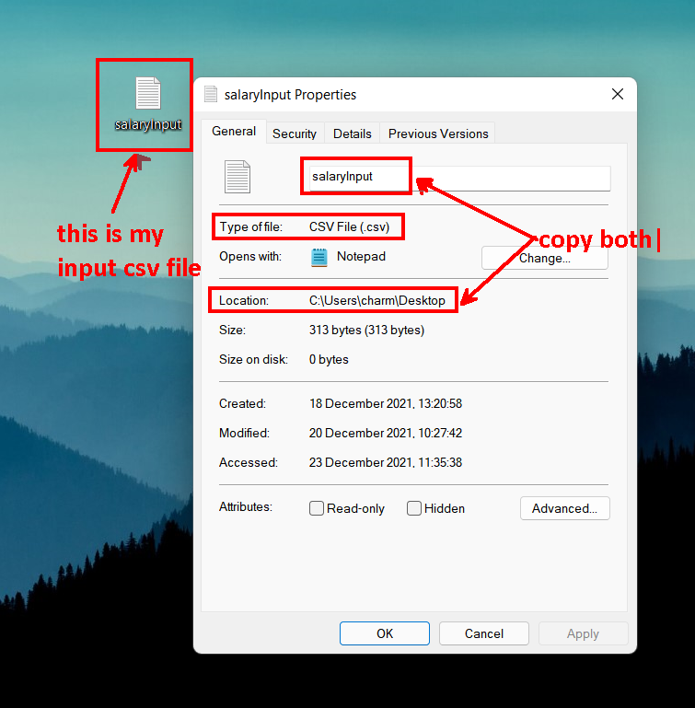

Step-4

Paste your old CSV file path like shown below , make sure file path must contains correct path & file name. now hit enter .

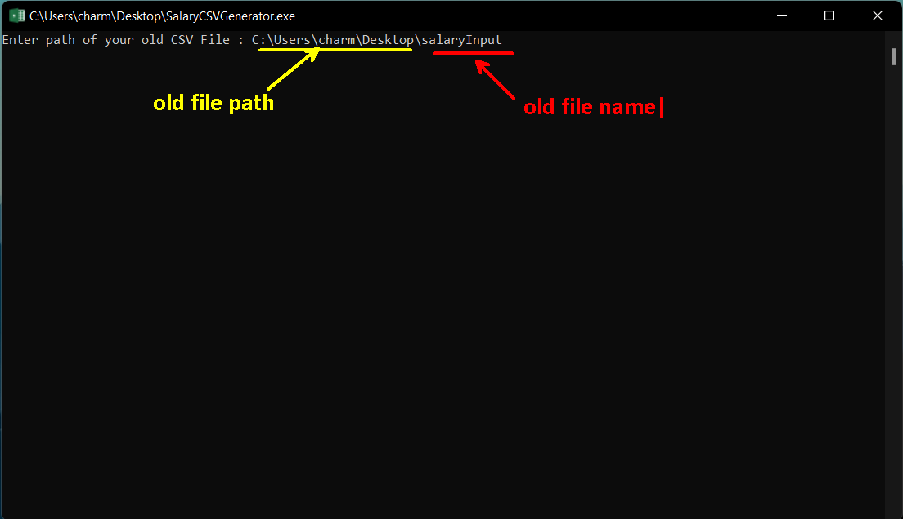

Step -6

Now it will ask for path where you want to save newly generated output file . mention desired location along with filename . Now hit enter .

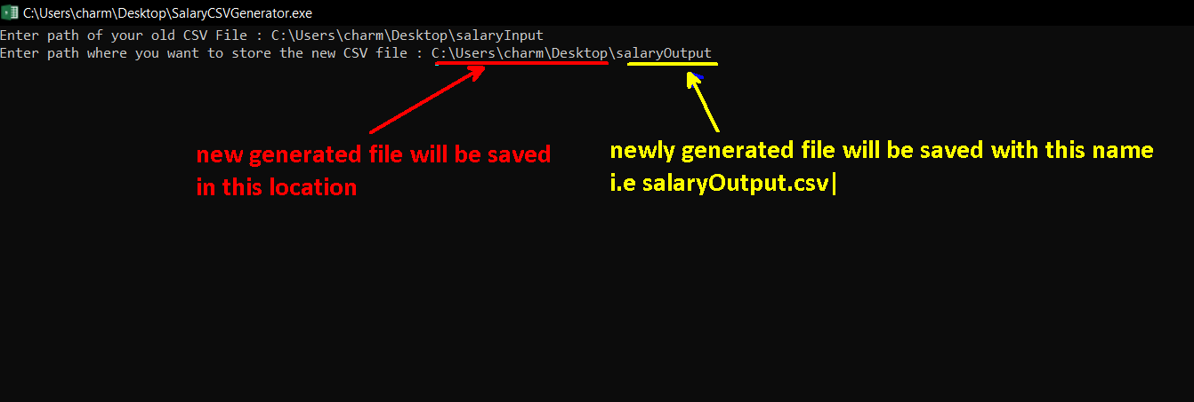

Step-7

After hitting enter button , Now check that output file location .

Voilla your new CSV file is generated .



Thank You!!